**MODBUS Connection with Node Js**  
MODBUS Simulator tool : **Modbus Slave**

Connection used : **TCP / IP**   
**Simulator Setup Steps :**

1. Open the Slave Simulator
2. Create a New Slave by select New button
3. Click the Setup and select the slave definition
4. Edit the configuration like below  
     
   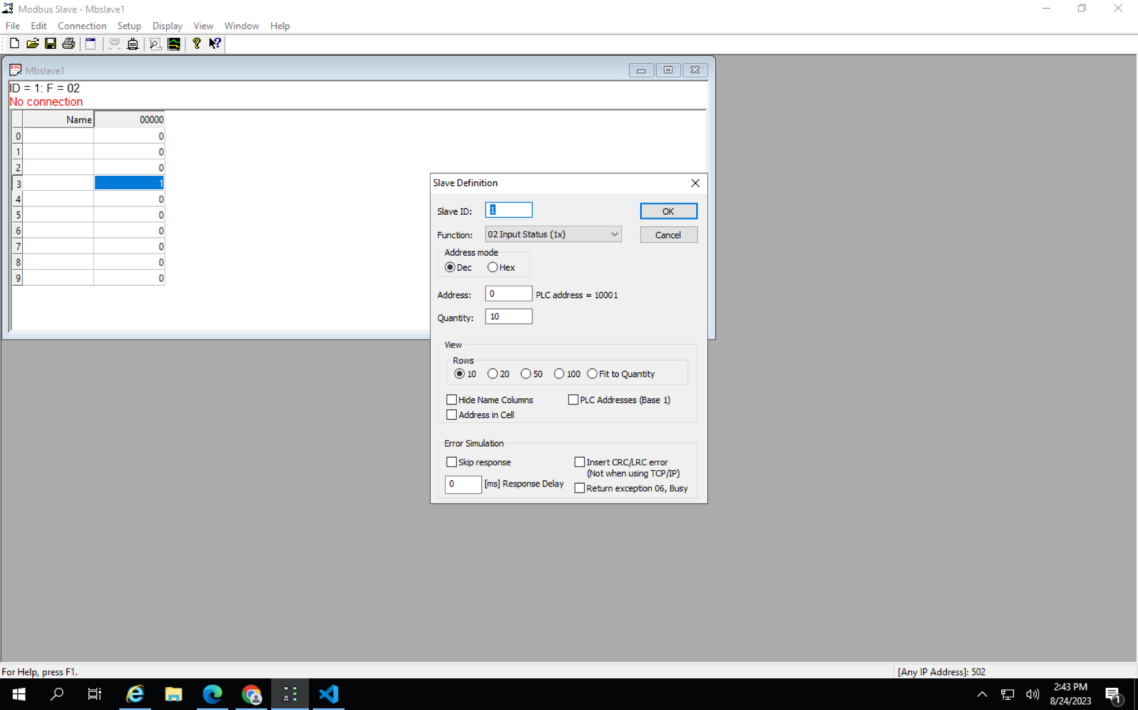
5. Select the function and choose the customized function based on your call method in your code and click ok.  
     
   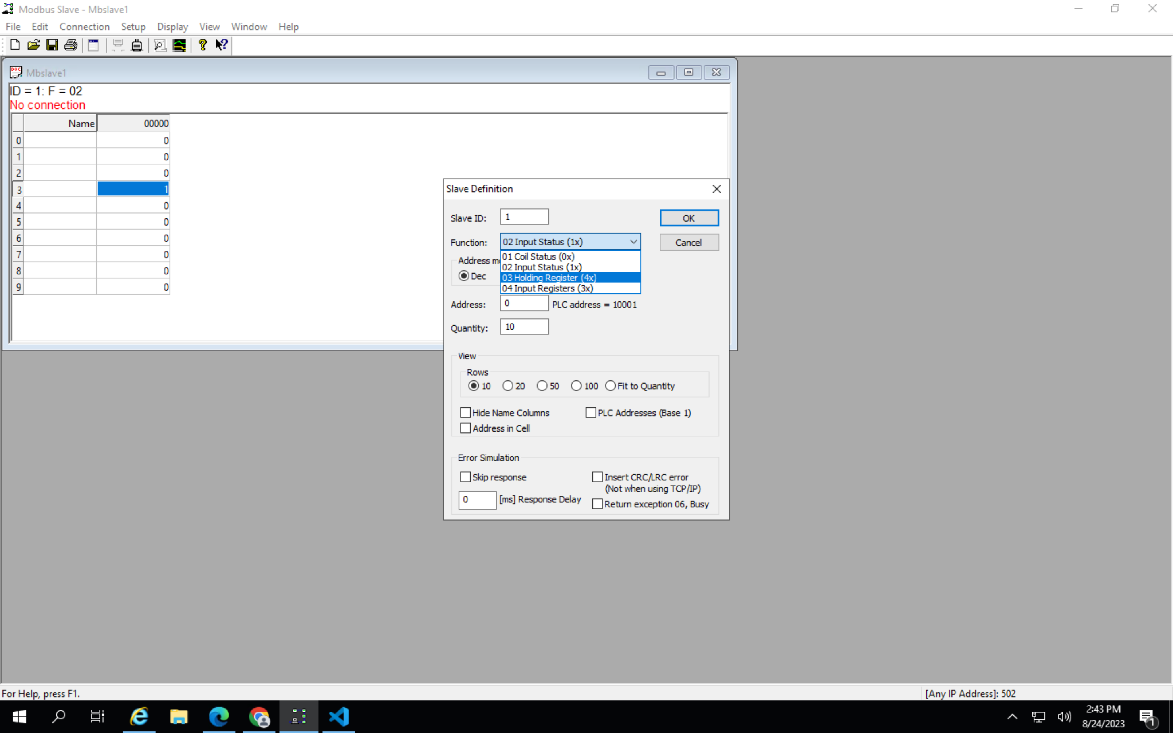
6. Click on the Connection menu and click connect  
   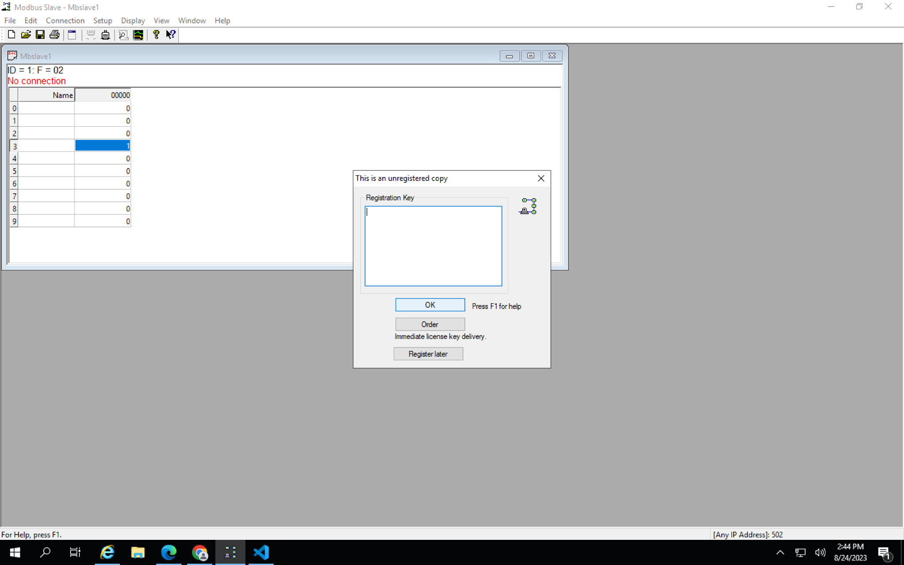
7. Click Ok and In the Connection setup screen choose the connection (Eg.Modbus Tcp/Ip).  
     
   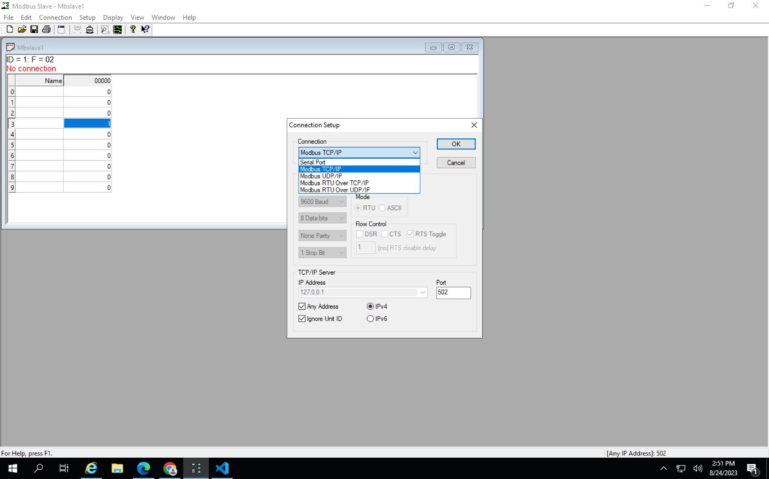
8. Click Ok and connection was done.

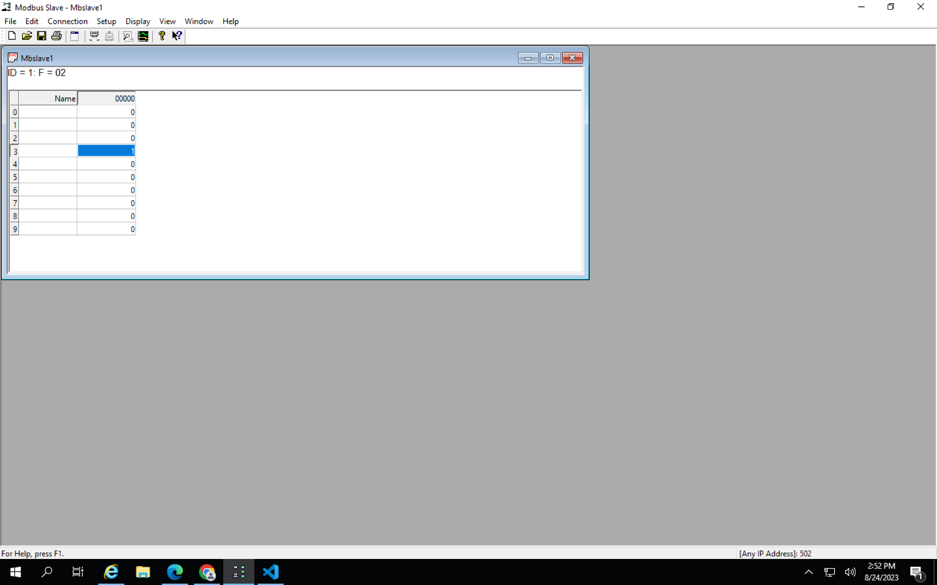

**Read / Write Methods to Simulator :**  
***readHoldingRegisters***

Slave Functions in slave definition : **Holding Registers**  
Make a call by using the ***readHoldingRegisters*** method.

Params : slaveId , startRegister,numRegisters  
  
O/P : Data from Salve table ( Read values: [ 0, 120, 40, 156, 0 ] )  
  
***WriteRegisters***

Slave Functions in slave definition : **Holding Registers**  
Make a call by using the ***WriteRegisters*** method.

Params : slaveId , registerAddress , valuetoWrite

O/P : Data added in the Salve table .  
  
***WriteCoils***

Slave Functions in slave definition : **Coil Status**  
Make a call by using the ***WriteCoils*** method.

Params : slaveId , registerAddress , true/false

O/P : Data added in the Salve table .

***readCoils***

Slave Functions in slave definition : **Coil Status**  
  
Make a call by using the ***readCoils*** method.

Params : slaveId ,startRegister ,numRegisters  
  
O/P : Data from Salve table ( data: [

false, true,

true, true,

false, false,

false, false

],

)

***readInputRegisters***

Slave Functions in slave definition : **Input Registers**

Make a call by using the ***readInputRegisters*** method.

Params : slaveId ,startRegister ,numRegisters  
  
O/P : Data from Salve table ( Read values: [ 0, 0, 0, 1 ] )

***readDiscreteInputs***

Slave Functions in slave definition : **Input status**

Make a call by using the ***readDiscreteInputs*** method.

Params : slaveId , startRegister, numRegisters  
  
O/P : Data from Salve table ( data: [

false, true,

true, true,

false, false,

false, false

],

)